**Entity Relationship Diagram**

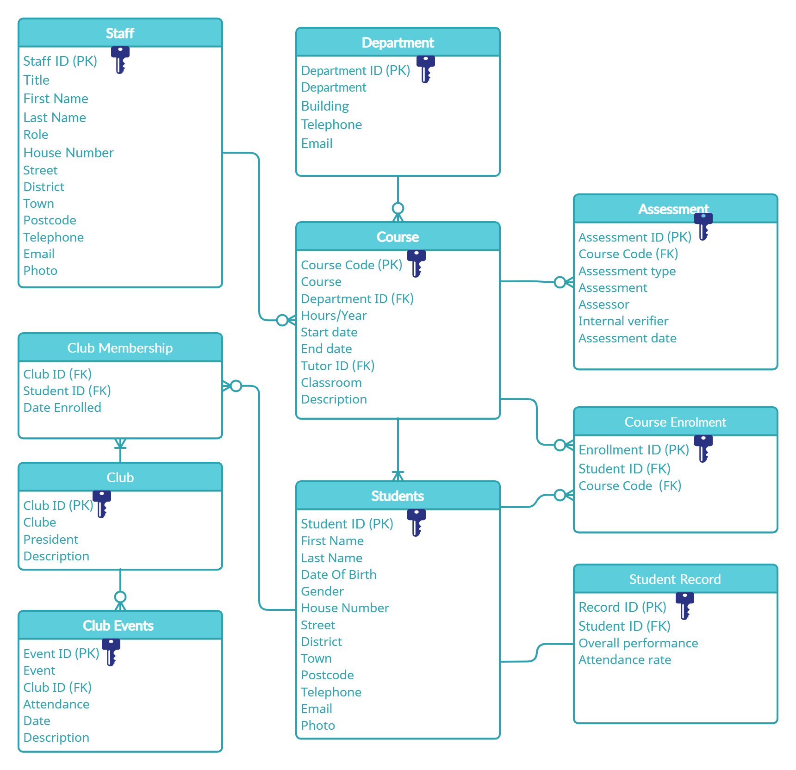

**Data Dictionary**

**Department Table:**

|  |  |  |
| --- | --- | --- |
| Field Name | Data Type | Size/Format |
| Department ID (PK) | AutoNumber | Long Integer |
| Department | Short Text | 20 characters |
| Building | Short Text | 1 character |
| Telephone | Short text | 11 characters |
| Email | Short text | 30 characters |

**Course Table**

|  |  |  |
| --- | --- | --- |
| Field Name | Data Type | Size/Format |
| Course Code (PK) | Short Text | 6 |
| Course | Short Text | 35 characters |
| Department ID (FK) | Number | Long Integer |
| Hours/Year | Short text | 3 |
| Start date | Short Date | Short Date |
| End date | Short Date | Short Date |
| Tutor ID | Number | Long Integer |
| Classroom | Short Text | 4 |
| Description | Short Text | 150 |

**Staff Table**

|  |  |  |
| --- | --- | --- |
| Field Name | Data Type | Size/Format |
| Staff ID (PK) | AutoNumber | Long Integer |
| Title | Short Text | 5 |
| First name | Short Text | 15 |
| Last name | Short Text | 15 |
| Role | Short text | 20 characters |
| House name/number | Short Text | 4 |
| Street | Short Text | 20 |
| District | Short Text | 20 |
| Town | Short Text | 20 |
| Postcode | Short Text | 8 |
| Telephone | Short Text | 11 |
| Email | Short text | 30 |
| Photo | Attachment |  |

**Students Table**

|  |  |  |
| --- | --- | --- |
| Field Name | Data Type | Size/Format |
| Student ID (PK) | AutoNumber | Long Integer |
| First name | Short Text | 15 |
| Last name | Short Text | 15 |
| Date of birth | Short Date | Short Date |
| Gender | Short Text | 10 |
| House name/number | Short Text | 4 |
| Street | Short Text | 20 |
| District | Short Text | 20 |
| Town | Short Text | 20 |
| Postcode | Short Text | 8 |
| Telephone | Short Text | 11 |
| Email | Short text | 30 |
| Photo | Attachment |  |

**Assessment Table**

|  |  |  |
| --- | --- | --- |
| Field Name | Data Type | Size/Format |
| Assessment ID (PK) | AutoNumber | Long Integer |
| Course Code (FK) | Short Text | 6 |
| Assessment type | Short Text | 25 |
| Assessment name | Short Text | 30 |
| Assessor name | Short Text | 30 |
| Internal verifier | Short Text | 30 |
| Assessment date | Date/Time | Short Date |

**Student Record Table**

|  |  |  |
| --- | --- | --- |
| Field Name | Data Type | Size/Format |
| Record ID (PK) | AutoNumber | Long Integer |
| Student ID (FK) | Number | Long Integer |
| Overall performance | Short Text | 17 |
| Attendance rate % | Short Text | 3 |

**Club Table**

|  |  |  |
| --- | --- | --- |
| Field Name | Data Type | Size/Format |
| Club ID (PK) | AutoNumber | Long Integer |
| Club Name | Short Text | 20 |
| Club President | Short Text | 30 |
| Description | Short Text | 150 |

**Club Membership Table**

|  |  |  |
| --- | --- | --- |
| Field Name | Data Type | Size/Format |
| Club ID (FK) | Number | Long Integer |
| Student ID (FK) | Number | Long Integer |
| Date Enrolled | Date/Time | Short Date |

**Club Events Table**

|  |  |  |
| --- | --- | --- |
| Field Name | Data Type | Size/Format |
| Event ID (PK) | AutoNumber | Long Integer |
| Event | Short Text | 40 |
| Club ID (FK) | Number | Long Integer |
| Attendance | Short Text | 3 |
| Event Date | Short Date | Short Date |
| Description | Short Text | 150 |

**Course Enrollment Table**

|  |  |  |
| --- | --- | --- |
| Field Name | Data Type | Size/Format |
| Enrollment ID (PK) | AutoNumber | Long Integer |
| Student ID | Number | Long Integer |
| Course Code | Short Text | 6 |

**Testing Table**

|  |  |  |  |  |
| --- | --- | --- | --- | --- |
| Test No. | Tested Item | Expected Result | Outcome | Evidence |
| 1 | Reports | The report should show the data from the query in a more organized and easy-to-read way. | Passed | Figure-1 |
| 2 | Forms | The form should allow the user to navigate the table and add new records. | Passed | Figure-2 |
| 3 | Queries | The query is expected to filter a search result according to a number of criteria. | Passed | Figure-3 |
| 4 | One-to-One realtionship between the Students table and the Student Record table. | Each student must have one record. | Passed | Figure-4 |
| 5 | One-to-Many realtionship between the club table and the club Membership table. | Every club has many members. | Passed | Figure-5 |
| 6 | Many-to- Many realtionship between the Course table and the Student table | Each course has many students and each student can study many courses. | Passed | Figure-6 |

**Figure-1**

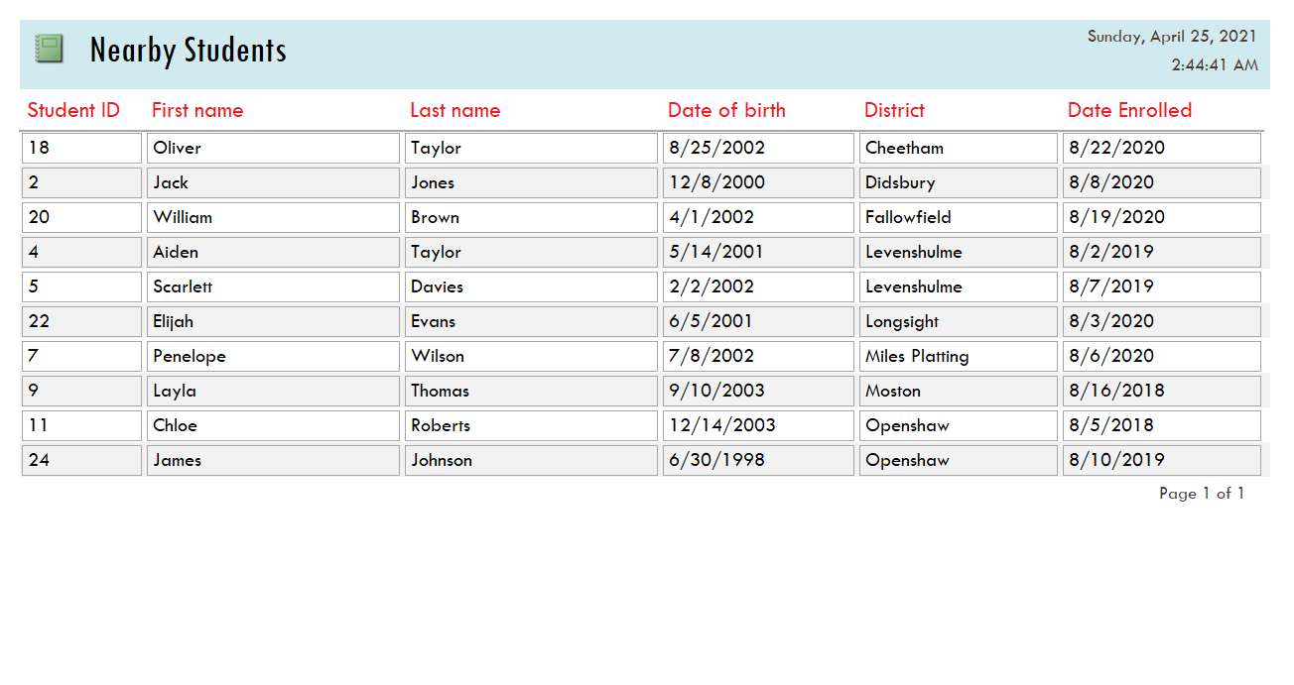

**Figure-2**

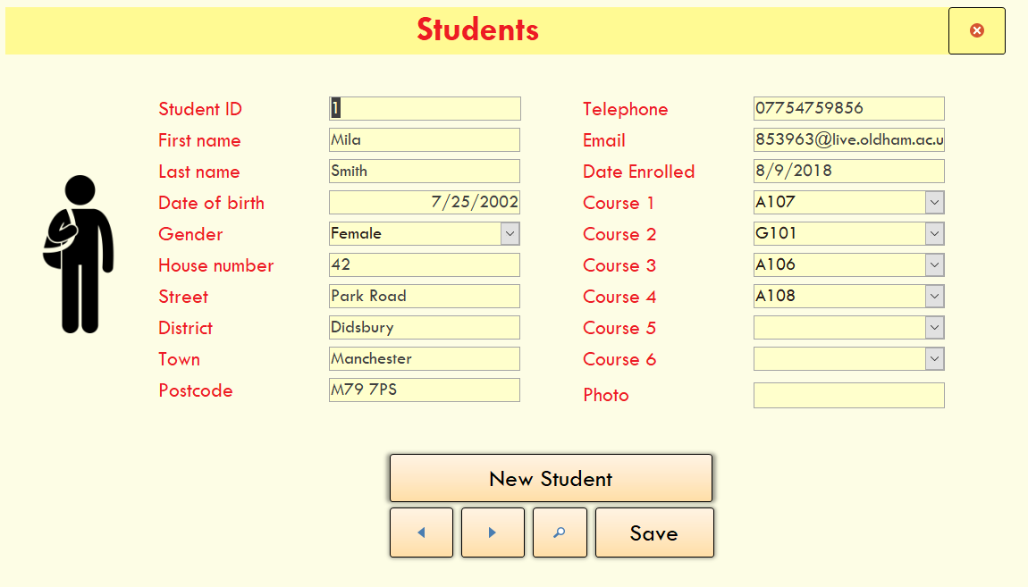

Add new record

Navigation

**Figure-3 A**

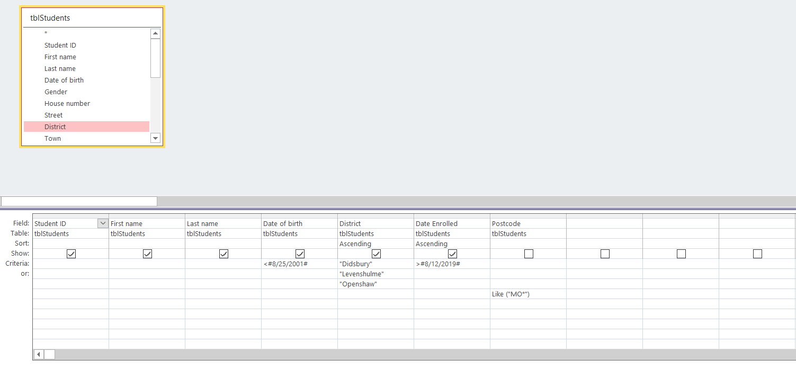

**Figure-3 B**

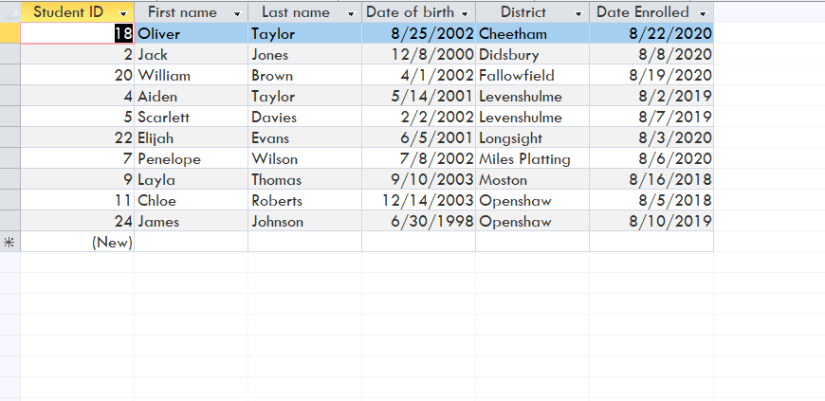

**Figure-4 A**

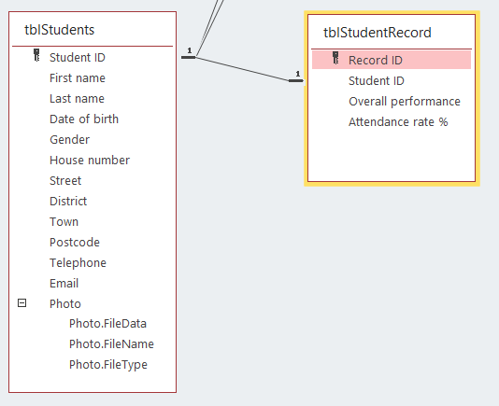

**Figure-4 B**

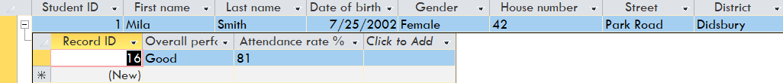

**Figure-5 A**

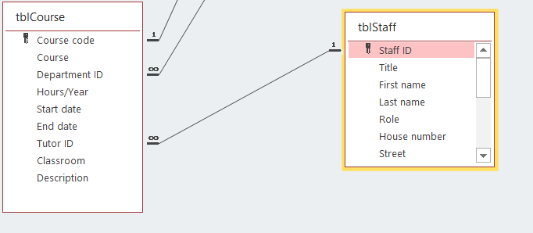

**Figure-5 B**

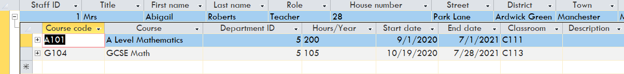

**Figure-6 A**

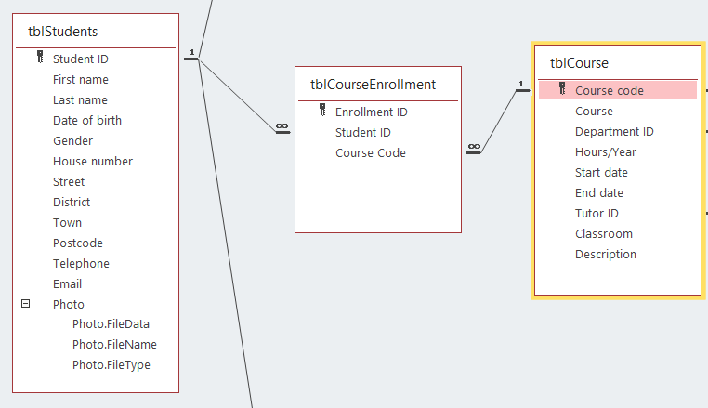

**Figure-6 B**

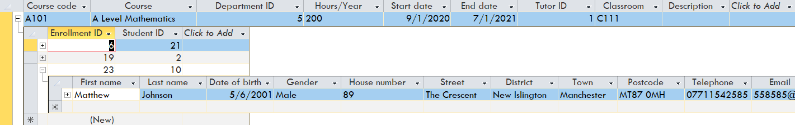

**Evaluation:**

After thorough testing, I can see that my database is fully functional. All tables in my database are in third normal form and contain all required data. Various types of relationships (one-to-one, one-to-many, and many-to-many) are also correctly sat between the different tables. With referential integrity, I was able to maintain the accuracy and consistency of my database. The primary and foreign keys also helped me to avoid any issues like data duplication. New data can be easily inserted into the database using the forms that were created for each table. Each form also contains some navigation buttons that can be used to move between the different records smoothly. A search button has also been added to the forms to allow the user to search for and modify data in any record easily. A number of queries have been created to answer some specific questions such as who are the students that were registered before 12/30/2019 or who are the students that live nearby? Data was imported from three queries into three reports. My reports are printable and well organized. In conclusion, I think my database is fully functional and ready to be used as a simple college database.